Programme of Study
Art

Year 10
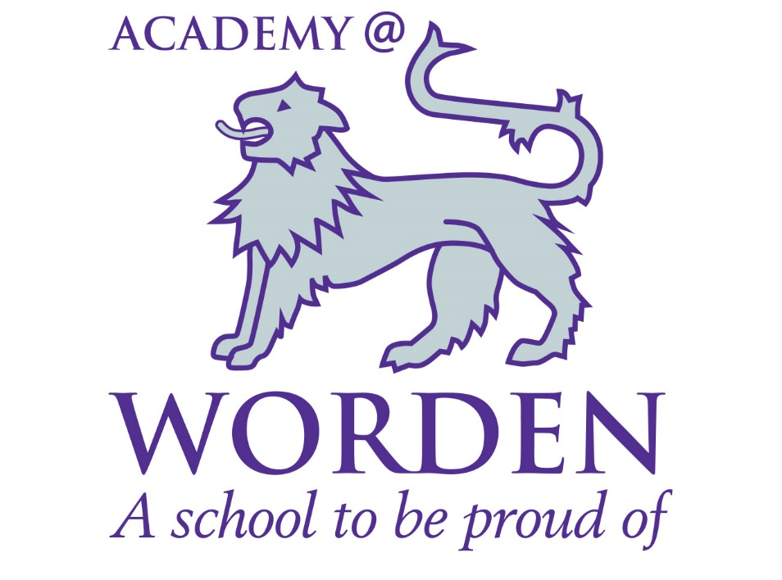

Topic: Artists Tool Kit: Understanding how, when, where and why formal elements are used in ART, DESIGN and CRAFT.

Theme | Learning Objectives |  | Learning Outcomes | Suggested main tasks | Core skills to be addressed (where appropriate)
SUMMARY OF OVERALL THEME:  Formal Elements | Understand formal elements that artists, designers and crafters employ to create work. |  | Students will use create a variety of small studies, recording observations and ideas in their sketch books which reflect their understanding of the context with in which artists create their work and the ways in which they work. perspective, tonal values to create form. These studies will begin to lay down the frame work for creating art work/ design which shows off their skills and understanding of perspective, proportion tonal values to create form. | Record experiments, observations, methods in different materials and media i.e painting, drawing, sculpting, printing. | Literacy | Students use an art dictionary which is incorporated into their book. The use of familiar punctuation symbols such as brackets to create contours. The use of annotation in books to describe work created by artists. AFL in the backs of their books.
 |  |  |  |  | Numeracy | The use of counting. Observing 90 degree angles to achieve vertical and horizontal lines. Scale and symmetry.
 |  |  |  |  | ICT | Students are asked to research illuminated letters online. Do use show my homework.
 |  |  |  |  | SMSC | Students consider how hot and cold colours can describe mood and atmosphere.
 |  |  |  |  | Subject Specific | Students are expected to understand how to use their sketch books to record ideas and skills which relate to artists, designers and crafters have employed, both traditional and modern.  Drafting ideas as well as annotating work of other artists. Creating samples of artists’, designers and crafters is key. As well as focussing on titles and control of font size when writing.
Colour | Understand how colours can be grouped. Considering the mixing of colours with light, solid and printing methods.  Using the material of paint and understanding it’s qualities.  The division of colours into warm and cool colours initially, although each colour has a warm and cool version of itself. The qualities that warm and cool colours have in an art work. |  | Students will understand that colours can be grouped into primary, secondary and tertiary colours as well as hot and cold.  The will understand how to use equipment to paint effectively and to create controlled colour wheels which show a distinct range of colours.  Students will use their skills to create a sample of an artists’ work. | Use of colour, primary, secondary, tertiary. Mixing of solid colour to create a variety of colours. To be able to name the groups of colours. Categorize colours as warm and cool colours. Create a range of tonal values in a variety of mark making methods to create a still life drawing.  Record information related to observations made from artists’ work.  Draw from observation using secondary research related to their chosen Topic/Exam Question  Use colour harmonies.  A colour wheel mixing primary colours to create secondary and tertiary colours.  Students will use colours to create hot and cold colours they observe in other artists’ work. | Literacy | primary colours, secondary and tertiary colours.  Warm and colour colours. Similes: Sun yellow, volcano red etc
 |  |  |  |  | Numeracy | Using a wheel, calculating and estimating addition of colours to create new colours. Spacial-awareness.
 |  |  |  |  | ICT | Use of separate primary colours to create colours using light compared to those used to when mixing solids or when printing.
 |  |  |  |  | SMSC
 |  |  |  |  | Subject Specific | Use of equipment particularly paint and brushes. How to use the room independently and with care. Paint to be used sparingly, finger nail blobs and paint brushes to be returned bristles up after use.  Use of brush, whilst painting, whole arm on table, bristles pointing toward line which is being painted along. Use of paint brush being drawn toward the body as this uses muscle tendency benefiting the artist with greater accuracy.
Tonal Values | Students will understand that tonal values are varying degrees of light and dark which can be achieved through several mark-making techniques in pencil colour.  Tonal values can be created using colour by using any respective colour as well as black and white to create tints and shades.  Looking specifically at using highlights as well as a wide range of tonal values to create portraits. |  | Students will be able to produce a range of differentiated lights and darks using coloured pencil. They will be able to identify the techniques used and their names.  The will use these skills to independently create a portrait using tonal values to show depth.  They will be able to mix and blend paint and printing ink to emulate the tones they see within an image. | Use tonal values confidently within work they produce.  Especially within observation work of both primary and secondary sources in a variety of work. | Literacy | Tonal Values, Tints and Shades, Pressure, layer shading. Cross-hatching, Hatching, Scumbling, Burnishing, Stippling. Line weight
 |  |  |  |  | Numeracy | Concept of a range of values.
 |  |  |  |  | ICT
 |  |  |  |  | SMSC
 |  |  |  |  | Subject Specific | Use of pencil to create layer shading is different to creating pressure shading.  Science behind adding too much pressure to fibres on paper which prevents uptake of new colour if they are depressed too much.  The concept of highlights and the use of tone within in colour to create tints and shades which can create depth within a piece.  The idea of creating a sample.
Form  2D and 3D | Students will understand the difference between shape and form. They will understand the techniques that allow artists use to create the illusion of depth on a 2D surface. |  | Students will understand that to create depth objects must show a greater number of sides. They must show tonal values which indicate in which direction the light is falling.  Students will be able to draw shapes and their corresponding forms so to add shadows and a range of tonal values to create the illusion of the 3 dimensional. | Students will draw shapes as well as 3D forms using the correct edges i.e contours vertical and horizontal lines and employ shading to show light direction.  Students will be able to employ theses skills in an independent task designed to look at their ability. For example, they may draw still life objects, or drawing from perspective. | Literacy | Shape, form, edge, depth, horizontal, vertical,
 |  |  |  |  | Numeracy | Time, 12 o’clock, 3 o’clock. Area. 90. Shape names, Form names, 2-dimensional, 3 dimensional.
 |  |  |  |  | ICT
 |  |  |  |  | SMSC
 |  |  |  |  | Subject Specific | Use of ruler to create one point perspective.
Texture | Students will explore the use of a ground to create surface texture which reflects the topic being studied. |  | Students will learn how use collage and create surface texture and tonal contrast to reflect the Fauvism  They will learn how to use a basic form of printing to transfer images.  Looking at the process of printing as a way of using surface texture to create an image. Using single colour Styrofoam printing to create a fauve style print. | They will learn how to use tissue paper and PVA to overlap and layer colours creating a colour full ground that should be smooth to the touch.  Control of the pencil with the Styrofoam to smooth clear channels that will not fill with ink.  The addition of printing ink to create an image that reflects their study of both the fauves and of tone. | Literacy | Surface texture, adjectives which describe texture.
 |  |  |  |  | Numeracy
 |  |  |  |  | ICT
 |  |  |  |  | SMSC
 |  |  |  |  | Subject Specific | Printing, mono printing, two colour prints, printing ink, lino, brayer, press, lino cutter, printing paper, masking, mesh, stencil.
Pattern | Students will explore the use pattern and rhythm and understand the difference between them. |  | Students will learn how to identify and create patterns and rhythm in a variety of ways.  They will learn how other artists have employed the use of pattern and rhythm to create various types of art or within craft, design and architecture.  Looking at the process of printing as a way of using surface texture to create an image. Using single colour Styrofoam printing as well as two colour printing.  Screen printing using a stencil. | Create own study of an artist, crafter, designer or architect who employs pattern or rhythm, using their media create a sample of their work.  Andy Warhol and his use of printing to create replicas, it’s effect and comment on the culture in which he grew up and societies changing ways ie consumerism.  Bridget Riley, Op art  Kath Kidston, Design classics, textile prints.  William Morris, Wallpaper  Chris Pisciak, Modern Motifs. | Literacy | Pattern, Rhythm, repetition, predicatable.
Figure Drawing | Students will explore figure drawing. The use of observational drawing and the concept of proportion. |  | Students will learn how use a variety of methods to record accurate information about the physical form.  They will explore using different media to record figures.  They will explore the use of various materials to draw with. | Opportunity to draw from a life model.  Experimentation with recording moving figures.  Drawing with speed.  Capturing stance, gate and posture through drawing the human form. | Literacy | Form, shape, line, weight of line, posture, stance, gate, torso, perspective, proportion, position.
 |  |  |  |  | Numeracy | Measuring, estimation, division, symmetry.
 |  |  |  |  | Subject Specific | Using pencil to measure by eye.  Using know division methods to measure body height.  Using specific proportional measurements to draw with accuracy.
Portraiture | Students will learn how to draw with proportion faces, including detailed features in the correct proportion.  Students will explore the use of colour artists, illustrators and designers have used to create portraits. |  | Students will understand how to draw using measurements to accurately place features and basic methods to help draw features with careful detail. Students will use skills learnt earlier to create portraits which show an ability to use observation drawing and tonal values.  Students will explore how Fauve artists’ created portraits using transfer of the image using oil pastel to achieve some form of copy. Paint to try and emulate colours and mark making used by the Fauves. | Students will learn proportions of face and how to use pencil as a form of measuring tool. Methods of using shape and line to create detailed facial features. How perspective alters the appearance of the face.  Students will create drawings from live models and from primary and secondary sources. | Literacy | Proportion, perspective, position, detail.
 |  |  |  |  | Numeracy | Measuring, estimation, division, symmetry.
 |  |  |  |  | ICT | Secondary Research
 |  |  |  |  | SMSC
 |  |  |  |  | Subject Specific | Drawing from observation, portraiture, facial expression.
 |  |  |  |  | Numeracy | Time, Date
 |  |  |  |  | ICT | Secondary Research
 |  |  |  |  | SMSC
 |  |  |  |  | Subject Specific | Using oil pastels, blending, observational drawing.  Annotation
Summative Assessment
Students will be marked at the back at the book using the descriptive words Emerging, Developing, Secure, Mastered and the numbers 2,5,8 within each area.
For some work peer assessment will be used. More specific categories will be identified and students will look at the success of their work writing comments about WWW and EBI.
HEAT is marked and an effort given for the work completed. Work done for home work is marked as an integral part of their studies in art as the time has been cut by half in this subject so homework is very important.
Students asses work together as a class when time permits.
Students self asses most lessons commenting on achievements and DIRT targets as well as Skill, Understanding, Effort, Progress and Behaviour.
C’s and R’s marks for each lesson are recorded as in the backs of books.

Extra Learning opportunities
HEAT opportunities |  | HEAT is set to support the lessons and is key to each topic. Homework set is mostly research or drawing to prepare for lessons or to identify individual ability during an independent task.
Extra curricular opportunities |  | ART CLUB on Tuesday’s after school.

Topic:: Book Art: The History of Art

Theme | Learning Objectives |  | Learning Outcomes | Suggested main tasks | Core skills to be addressed (where appropriate)
Cave Painting | To think about mark making and it’s importance to record ideas and beliefs. To be able to research and show a wide range images related to the topic. Presentation of work shows reflects main themes.  Analysis and comparison of artists, designers and crafters work is through, explored both visually and in concise annotation. |  | CAVE PAINTINGS  SURFACE TEXTURE EXPLORED, MATERIALS AND METHODS EXAMPLED  STUDY ANOTHER ARTISTS WHO USES SIMILAR MATERIALS, METHODS AND CONTENT FROM A MORE MODERN TIME. | CREATE OWN SAMPLES OF CAVEPAINTINGS  COMPARE METHODS, MATERIALS, MEANINGS, MEDIA.  CREATE PAGES WHICH COMPARE AND CONTRAST THE WORK OF THE CAVE PAINTERS AND THOSE OF THE OTHER ARTIST | Literacy | Analysis, Method, Material, Meaning
 |  |  |  |  | Numeracy | Timeline
 |  |  |  |  | ICT | Secondary Research
 |  |  |  |  | SMSC | SURFACE TEXTURE, Artist Analysis, Work is marked in line with the exam board specification.
 |  |  |  |  | Subject Specific
Egyptian Art | To understand the development of depiction and the importance of artwork to human civilization. To be able to research and show a wide range images related to the topic. Presentation of work shows reflects main themes.  Analysis and comparison of artists, designers and crafters work is through, explored both visually and in concise annotation. |  | Visually and through annotation explore Egyptian Art and their use of the figure. Including the use of proportion to show importance rather than perspective.  Invesitgate the use of planes and the reason for their tomb paintings.  Composition and background. | Create own Egyptian Art work using their chosen title to make a connection. Thinking particularly about the showing the importance of objects and subjects, showing an ability to use the style of tomb paintings. | Literacy | Proportion, perspective.
 |  |  |  |  | Numeracy | Measurement, proportion.
 |  |  |  |  | ICT | Secondary and primary research.
 |  |  |  |  | SMSC | Life, death, the afterlife.
 |  |  |  |  | Subject Specific | Proportion, Figure Drawing, Painting, Composition
Medieval Art:  The Icon  Illuminated Manuscripts | To understand and develop a greater knowledge of how images were used to educate and their value to record history in a variety of new media. To be able to research and show a wide range images related to the topic. Presentation of work shows reflects main themes.  Analysis and comparison of artists, designers and crafters work is through, explored both visually and in concise annotation. |  | Think about craftsmen and the origins of illustration and the use of tapestry to show historical events. | Create an illuminated manuscript, paper, or a tapestry which is an example of the craft work they have studied. Using their chosen titles create a piece of artwork that relates to their ideas and reflects the concepts, methods | Literacy
 |  |  |  |  | Numeracy
 |  |  |  |  | ICT
 |  |  |  |  | SMSC
 |  |  |  |  | Subject Specific
The Renaissance |  |  |  |  | Literacy
 |  |  |  |  | Numeracy
 |  |  |  |  | ICT
 |  |  |  |  | SMSC
 |  |  |  |  | Subject Specific
Impressionism |  |  |  |  | Literacy
 |  |  |  |  | Numeracy
 |  |  |  |  | ICT
 |  |  |  |  | SMSC
 |  |  |  |  | Subject Specific
Dadaism |  |  |  |  | Literacy
 |  |  |  |  | Numeracy
 |  |  |  |  | ICT
 |  |  |  |  | SMSC
 |  |  |  |  | Subject Specific
Fauvism |  |  |  |  | Literacy
 |  |  |  |  | Numeracy
 |  |  |  |  | ICT
 |  |  |  |  | SMSC
 |  |  |  |  | Subject Specific
Post Impressionism  Symbolism |  |  |  |  | Literacy
 |  |  |  |  | Numeracy
 |  |  |  |  | ICT
 |  |  |  |  | SMSC
 |  |  |  |  | Subject Specific
Futurism |  |  |  |  | Literacy
 |  |  |  |  | Numeracy
 |  |  |  |  | ICT
 |  |  |  |  | SMSC
 |  |  |  |  | Subject Specific
Pop Art |  |  |  |  | Literacy
 |  |  |  |  | Numeracy
 |  |  |  |  | ICT
 |  |  |  |  | SMSC
 |  |  |  |  | Subject Specific
Summative Assessment
An overview of the summative assessment for this topic

Extra Learning opportunities
HEAT opportunities |  | Opportunities for HEAT or examples of HEAT tasks that should be used
Extra curricular opportunities |  | Extra curricular opportunities such as trips, clubs, competitions etc

Topic: Containers
Theme | Learning Objectives |  | Learning Outcomes | Suggested main tasks | Core skills to be addressed (where appropriate)
Mock Exam | Individuals will choose from a past paper a particular title to develop. |  | Students will practise developing ideas and ensuring that each Assessment Objective is fully developed within the project.  Students will become familiar with the four assessment objectives. They will Investigate, Select, Experiment, and Record through made, written and verbal responses.  These responses must be individual and should not be heavily influenced by the teacher, there should be guidance but students study should lead them to create their own work in the light of their research. | Students will follow a step by step approach to each to their project, making sure that they are able to work independently as much as possible in practise for the main exam.  Students are not required to create a final outcome but must be in the process of developing a response to the title they have chosen.  Students will need to understand the time allocation and the need to create work that must be made during a 10 hour exam in response the title they have chosen. Students may opt to further develop their idea in this time. | Literacy | Outline of literacy skills that should be addressed in this subtopic e.g.
 |  |  |  |  | Numeracy | Outline of numeracy skills that should be addressed in this subtopic e.g. interpretation of graphs
 |  |  |  |  | ICT | Outline of ICT skills that should be addressed in this subtopic e.g. Powerpoint
 |  |  |  |  | SMSC | Outline of SMSC that should be addressed in this subtopic e.g.
 |  |  |  |  | Subject Specific | Outline of subject specific skills that should be addressed in this subtopic e.g. GIS
Summative Assessment
An overview of the summative assessment for this topic

Extra Learning opportunities
HEAT opportunities |  | Opportunities for HEAT or examples of HEAT tasks that should be used
Extra curricular opportunities |  | Extra curricular opportunities such as trips, clubs, competitions etc

Programme of Study skills map

 | Literacy | Numeracy | ICT | SMSC | Citizenship | PSHE
Colour Lesson 1-2 | Primary colours, secondary and tertiary colours.  Warm and colour colours. Similes: Sun yellow, volcano red etc | Using a wheel, calculating and estimating addition of colours to create new colours. Spacial-awareness. | Use of separate primary colours to create colours using light compared to those used to when mixing solids or when printing.
Tonal Values Lesson 3, | Tonal Values, Tints and Shades, Pressure, layer shading. Cross-hatching, Hatching, Scumbling, Burnishing, Stippling. Line weight | Concept of a range of values.
Shape & Form Lesson 4,5 | Shape, form, edge, depth, horizontal, vertical, | Time, 12 o’clock, 3 o’clock. Area. 90
Texture  Lesson 6 | Surface texture, adjectives which describe texture.
Fauvism  Lesson 7 | Fauvism, Context  Secondary Research | Time |  | Fauvism colour as meaning. |  | WWI
Portraiture  Lesson 8-12 | Context, Where, When, Why, Who  Perspective, Planes, Optical Illusion | Scale,
Printing Lesson 13-17 | Styrafoam, Brayer, | Time, Date
Luke Dixon  Lesson 18-20 | Artist, Illustrator, | Increase and decrease.
Spare lessons
Of which 2 are often taken up by another activity, Autumn:PSHE day
Spring: Interviews/Trip Summer: Exams/Sports Day
Should 2 lessons remain to be spent on either
consolidation of knowledge or develop ideas which further.

